|  |  |  |
| --- | --- | --- |
| /  SCHOOL OF INFORMATION AND TECHNOLOGY | | |
| NAME: Dale Matthew R. Boquiren | DATE PERFORMED: 09/11/2024 |  |
| Section: IDC1 | DATE SUBMITTED: 09/11/2024 |

# SYSADM1 – Managing Services in Linux

# Requirement:

* A virtual machine running Linux

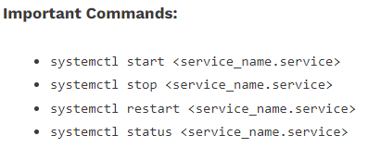

Complete this lab as follows:

Use the service –status-all command to list all active and inactive services.

List down active and inactive services in the table below. Provide five (5) services for each column.

|  |  |
| --- | --- |
| **Active** | **Inactive** |
| alsa-utils | anacron |
| apport | apparmor |
| cron | bluetooth |
| cups | console-setup.sh |
| dbus | cryptdisks |

SS: 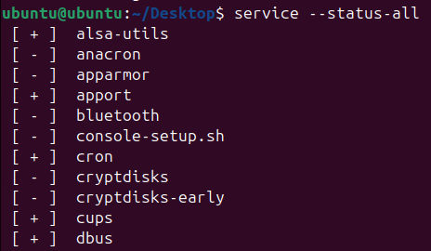

Start the Bluetooth service using the systemctl command.

Ex. sudo systemctl start httpd

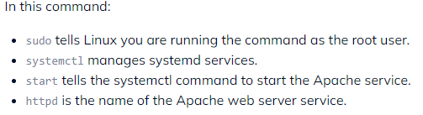

Check the status of the Bluetooth service. What is its status?  
- The status of Bluetooth is inactive(dead). It won’t start because condition is unmet.

SS: 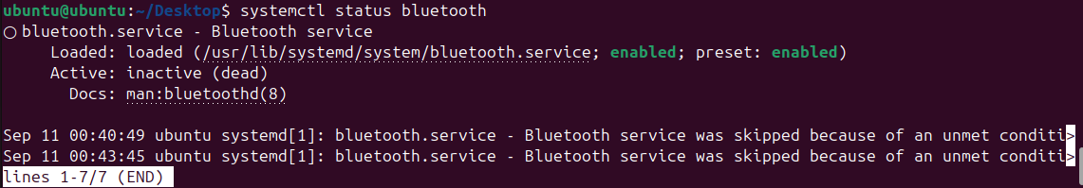

Check the status of the cups services. Since when was it running?  
- Cups services was running since Wed 2024-09-11 00:26:00 UTC -19 minutes.

SS: 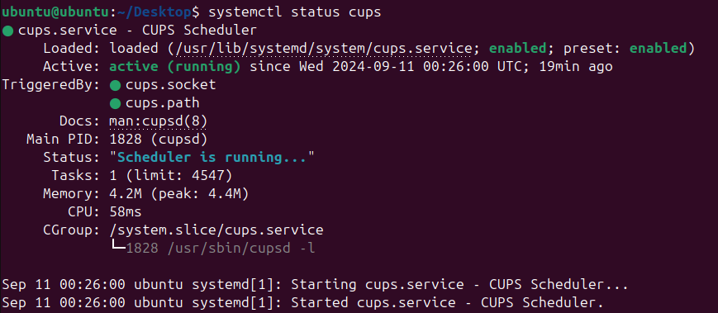

Stop cups services.



Verify if the service was stopped.

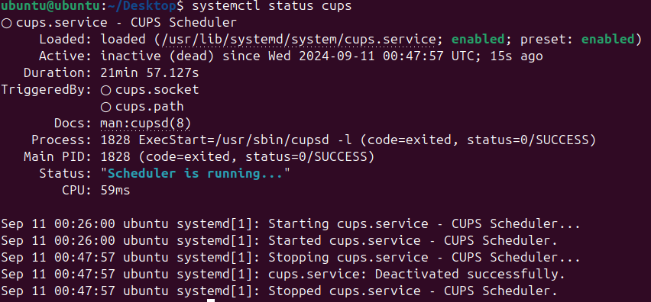

Restart the cups services



Verify if the service was restarted.

* Cup services starts running again.

